**Q1.**

My choice would be BigQuery. BigQuery is a popular analytics platform that offers free data exporting and charge loading. Its pricing structure includes cost of demand, fixed-rate amount, data transmission and storage, and level 0. On-demand pricing is charged based on the volume of data processed and read from storage, using Terabytes (TB) as the unit of measurement. Flat-rate pricing is a reliable substitute for businesses with large or irregular query volumes.

Data transmission and storage are charged for the amount of data stored, and streaming data into BigQuery may result in additional costs. Google's official documentation provides the most up-to-date information on these limits.

BigQuery's ability to efficiently manage vast volumes of data and metadata is crucial for companies working with complex, large-scale datasets. Its metadata management approach does not compromise query speed, making it a strong and capable analytics platform. However, cost can play a significant role in choosing BigQuery. Companies should consider their spending plan, the volume of data, the complexity of queries, and the frequency of use when assessing their unique data processing requirements. BigQuery may be less costly than other options.

**Q2.**

Two common schema types in data warehousing are the star schema and the snowflake schema.

Star Schema: The most popular and basic structure in data warehousing is the star schema. It consists of more dimension tables that can be related to an unlimited number of fact tables. The fact table is linked to dimension tables via foreign key connections and has aggregate able quantitative data on income. Denormalized dimension tables are designed to conduct queries more quickly and provide descriptive data about the facts in the fact table. The fact table is positioned in the middle of the starred-shaped design, encircled by dimension tables, thus the name "star schema".

Snowflake Schema: It involves normalizing dimension data into several linked tables. It is an elaboration of the Star Schema. The dimension tables are arranged in a hierarchy, and the relationships between them are standardized by the snowflake schema. Even while this standardization could help reduce storage requirements, getting the data might require complex searches involving several joins. The schema diagram's shape, which had several branches that resembled snowflakes, gave rise to the term "snowflake".

**Q3.**

Small Entrepreneurship: Considering the Budget: Effectiveness in terms of costs is essential for a small organization with constrained resources. BigQuery's pricing structure, which includes a free tier, makes it an appealing option for smaller firms attempting to limit costs when they are just getting started with data analytics.

Easy to Utilize: BigQuery's graphical user interface and integration with other Google services make it a potentially useful tool for small firms with limited IT resources. It has a short learning curve so users may start using it straight away. In conclusion, I choose small businesses over large ones since Snowflake's strong security features, capacity to handle a variety of workloads, and scalability may be better suited to large firms' complicated data requirements. Ultimately, the choice must take into account the specific data goals of the organization, the resources at hand, and any budgetary limitations.

Scalability of necessities: Snowflake's massive scalability may not be necessary for small organizations. Given that BigQuery can handle a broad variety of data sizes, it is suitable for companies with modest data demands.

**Q4.**

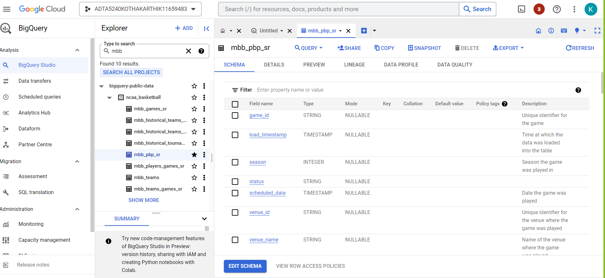

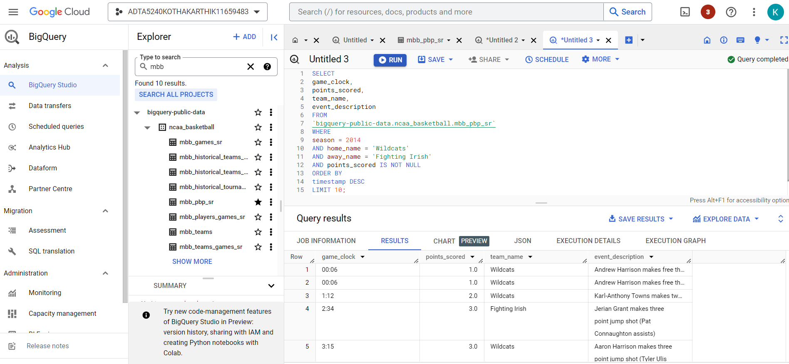

**References and Citations:**

Greengard, S. (2022, July 6). BigQuery vs. Snowflake: Data Warehouse Comparison 2022 | eWEEK. eWEEK. https://www.eweek.com/big-data-and-analytics/bigquery-vs-snowflake/

In-Text Citation: (Greengard, 2022)

Edara, P., & Pasumansky, M. (2021, July 1). Big metadata. Proceedings of the VLDB Endowment; Association for Computing Machinery. https://doi.org/10.14778/3476311.3476385

In-Text Citation: (Edara & Pasumansky, 2021)